April 1, 2020

To Whom It May Concern:

Genesta Michelle Welch-Day (also known as Sonnie Day) has been an independent contractor for Prison Fellowship in Michigan for 12 years. She performs concerts for incarcerated men and women throughout the state. Prisoners enjoy both her music and her stories. We are looking forward to working with her again in the near future. However, due to the COVID-19 pandemic, all programming held inside prisons has been canceled until further notice as prisons are closed to the public.

Feel free to contact me should you have any questions: 248-886-0881 or denise_harris@pfm.org

Sincerely,
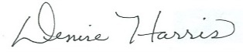

Denise Harris
Field Director, Michigan

